COLLEGE AFRICA GROUP
Corporate Training and AI Consulting
CLAUDE FOR BUSINESS
CORPORATE TRAINING PROGRAMME
One-Day Hands-On Workplace Productivity Course
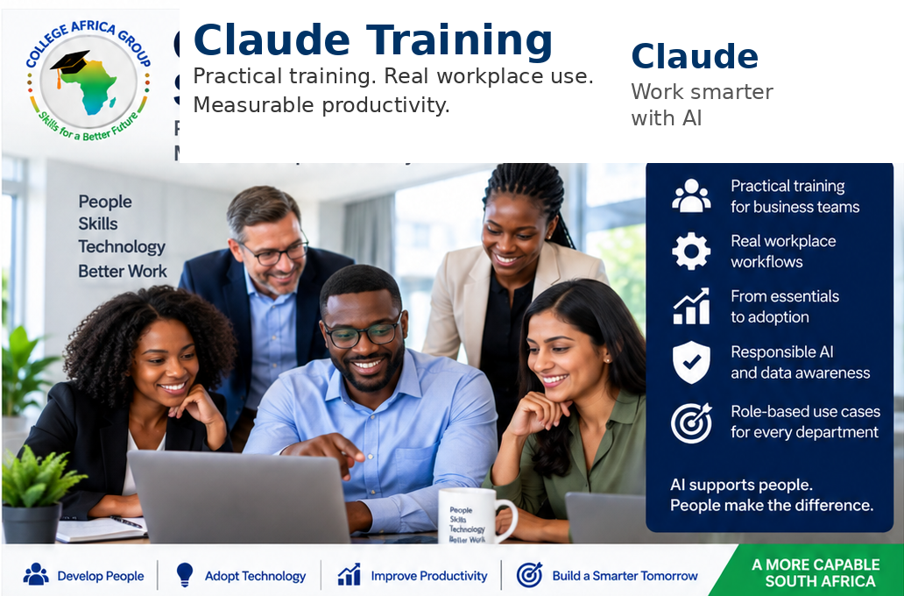
Start with the source. Check the process. Use AI with purpose.
By Arnold and Jenny Muscat
www.collegeafricagroup.com | sales@collegeafricagroup.com | 083 778 4903

Programme overview
This practical one-day corporate programme helps everyday business users apply Claude and generative AI to real workplace tasks.
Delegates learn how to work more efficiently, improve processes, analyse information, save time and produce reliable workplace outputs that are validated against the original source data.
The programme is practical rather than technical and does not require programming or specialist AI knowledge.

Course method
Source Data > Process > Required Output > AI > Validate Against the Source
Delegates learn to identify the authoritative source, check whether the existing process is working, define the required result, use AI deliberately and validate the output against the source. If the process is unclear or broken, the first step is to correct the process rather than automate it.

Who should attend
• Business professionals who use Claude in their daily work.
• Managers, administrators, project teams and customer-facing employees.
• Mixed groups from finance, HR, operations, sales and support functions.

Learning outcomes
• Explain the practical capabilities and limitations of generative AI and Claude.
• Apply responsible-use, confidentiality, POPIA and validation principles.
• Use the CAG Source-to-Output Method to evaluate a workplace task.
• Import, structure, analyse and compare workplace information in Excel.
• Summarise communication and meeting content into useful outputs.
• Compare tender requirements with product information and previous responses.

Course content

Module 1 AI and Claude in plain English
A brief introduction establishes realistic expectations before the practical work begins.
• What generative AI and Claude can and cannot do.
• Where AI can reduce repetitive effort in ordinary workplace tasks.
• Why fluent and convincing outputs are not guaranteed to be correct.

Module 2 Responsible use and validation
• Hallucinations, weak evidence and incorrect outputs.
• Confidentiality, sensitive information and POPIA awareness.
• Human accountability and checking important outputs against the source.

Module 3 The CAG Source-to-Output Method
• Source Data: identify the authoritative and current information.
• Process: understand the existing steps and ask whether the process is broken.
• Required Output: define the result, audience, format and standard.
• AI: decide where AI can assist and provide a clear instruction.
• Validate Against the Source: check facts, figures, omissions and assumptions.

Practical prompting demonstration
Prompting is introduced briefly and reinforced during the exercises. Delegates use a practical pattern: source, task, required output, constraints and validation.

Module 4 Claude and Excel practical workshop
Excel receives the largest practical allocation and is completed before lunch. The exercises are suitable for general business users and do not require specialist accounting knowledge.

Exercise 1 Import and structure captured information
• Turn untidy captured information into a structured Excel table.
• Standardise fields and identify blanks, duplicates or inconsistencies.
• Check the imported table against the original source.

Exercise 2 Turn business data into a dashboard
• Create a practical dashboard from supplied workplace data.
• Create useful calculations, summaries, indicators and charts.
• Check dashboard totals and findings against the source data.

Exercise 3 Compare customer orders with deliveries
• Compare a small sample manually before using AI.
• Identify outstanding orders, unmatched deliveries and material differences.
• Use AI-assisted formulas or matching logic and verify the exceptions.

Excel skills reinforced
Tables, sorting, filtering, data quality, formula explanation, exception analysis and concise management commentary.
Control principle Start with the source. Check the process. Verify every important result.

Afternoon workplace productivity session
The afternoon applies the same source-led method to common communication and document tasks.
Delegates complete short guided activities using supplied workplace information.

Module 5 Five practical productivity ideas
A short show-and-tell introduces five ordinary uses without attempting to teach every available feature.
• Summarise an email thread.
• Draft or improve a professional response.
• Turn a transcription into decisions and actions.
• Compare documents or sets of information.
• Convert source information into a report or presentation outline.

Module 6 Communication and meeting follow-up
• Summarise the supplied email, notes or transcription.
• Identify outstanding questions, decisions, actions, owners and deadlines.
• Prepare follow-up communication and verify it against the source.

Module 7 Tender and document comparison
Delegates compare a new, shortened tender specification with current product or service information and two or three previous tender responses.
• Identify material changes, mandatory requirements and missing evidence.
• Determine which previous responses may be reused and which must be updated.
• Identify all potentially material differences and rank the five most important.
• Produce a comparison showing the source reference, difference, impact and required action.
• Validate each important finding against the tender or supporting source document.
Tender principle AI assists with the review. The tender documents remain the source of truth.

Module 8 Workplace application and questions
Delegates apply the course method to their own responsibilities and identify suitable next steps.
• Identify the authoritative source information.
• Check whether the current process is clear, consistent and working.
• Define the required output and how it will be validated.
• Decide where AI can add value without removing necessary human judgement.
Do not automate confusion. Fix the process, then decide where AI adds value.

Recommended one-day schedule
Time | Session
09h00-09h20 | Introduction and workplace discussion
09h20-09h45 | Responsible AI, POPIA and the Source-to-Output Method
09h45-10h00 | Practical prompting demonstration
10h00-10h15 | Morning break
10h15-12h30 | Excel practical workshop
12h30-13h15 | Lunch
13h15-13h35 | Five practical productivity ideas
13h35-14h05 | Communication and meeting follow-up
14h05-14h20 | Afternoon break
14h20-15h05 | Tender and document comparison
15h05-15h30 | Workplace application and Q&A

Delivery and preparation
• One-day onsite or instructor-led virtual corporate programme.
• Prepared practical files supplied before training.
• Delegates should confirm that their Claude access is working.
• The organisation should confirm which workplace information may be used during training.
Better Processes. Stronger Skills. Smarter AI.

